This plugin records Birth, Marriage and Death details from the General Registers Office Indexes using Civil Registration Index Template as a citation.
Before it can be used, the "Civil Registration Index" template from the Essentials collection must added. This can be done by selecting Tools>Source Template Definitions and then highlight the template(s) and add to project.
The first time you use this plug in, you will need to identify, or create, the appropriate source record.
To do this first, select the region and then press the "source" button of the bottom of the screen. This will list matching source records for the template, type and region. If there is only one matching source record it will select that. If there is more than one, you will be asked to choose which to use. If there are none, you will be asked to create one, when you can add extra fields such as the Repository for the source.
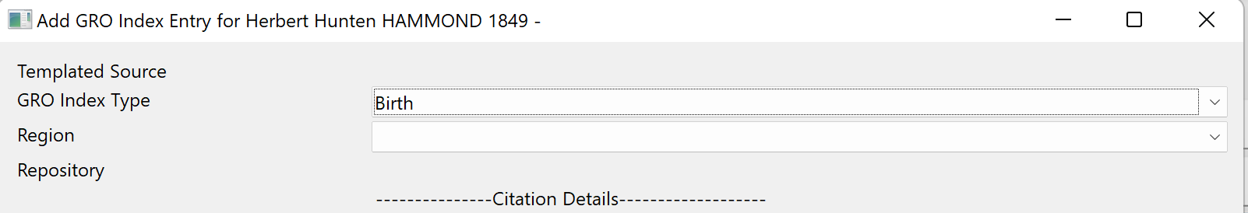
To do this first, select the region and then press the "source" button of the bottom of the screen. This will list matching source records for the template, type and region. If there is only one matching source record it will select that. If there is more than one, you will be asked to choose which to use. If there are none, you will be asked to create one, when you can add extra fields such as the Repository for the source.

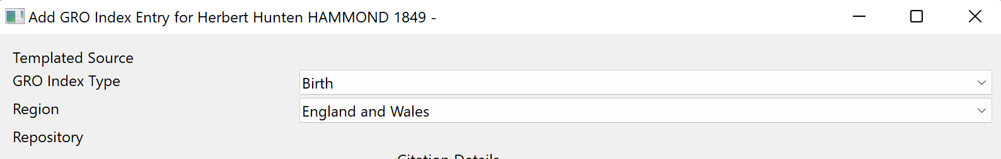
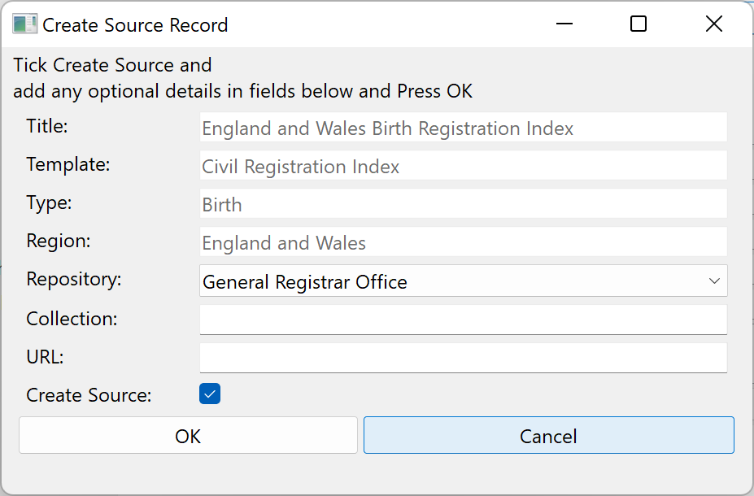
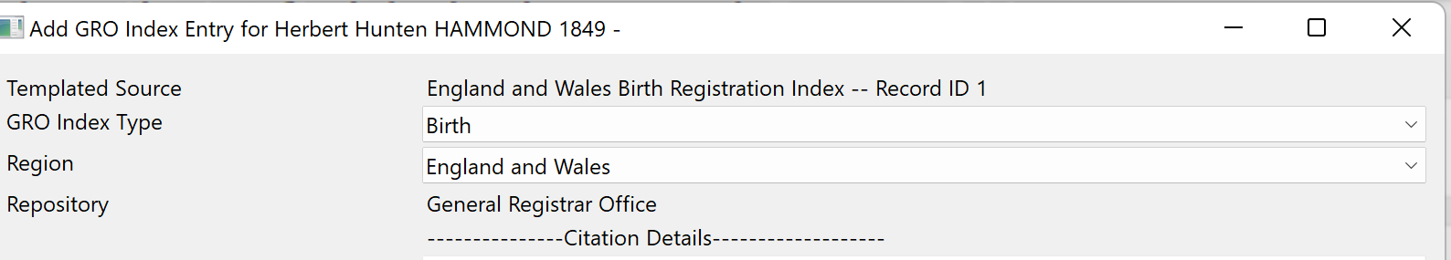
You can set up different source record for different regions (or change the selected source record for future use).
When you save an entry, the current region and template is remembered for future use, as is the assessment rating and Address (but not the place).
For the actual citation, you can overtype the name for the citation, but the name will NOT be changed. You must provide a Registration Date, Registration District and Reference.
The Registration District can be type in manually or selected from the list of places.
You can select to update the event date (Birth, Death or Marriage) with the registration date you have entered by ensuring that the Update Date checkbox is ticked. Similarly, you can update the event place by ensuring that the Update Date checkbox is ticked.
In the case of a Death entry, you can choose to update the birth date if can enter a birth date.
By pressing the "Save" button, the relevant facts and events are updated where requested, and the citation saved.

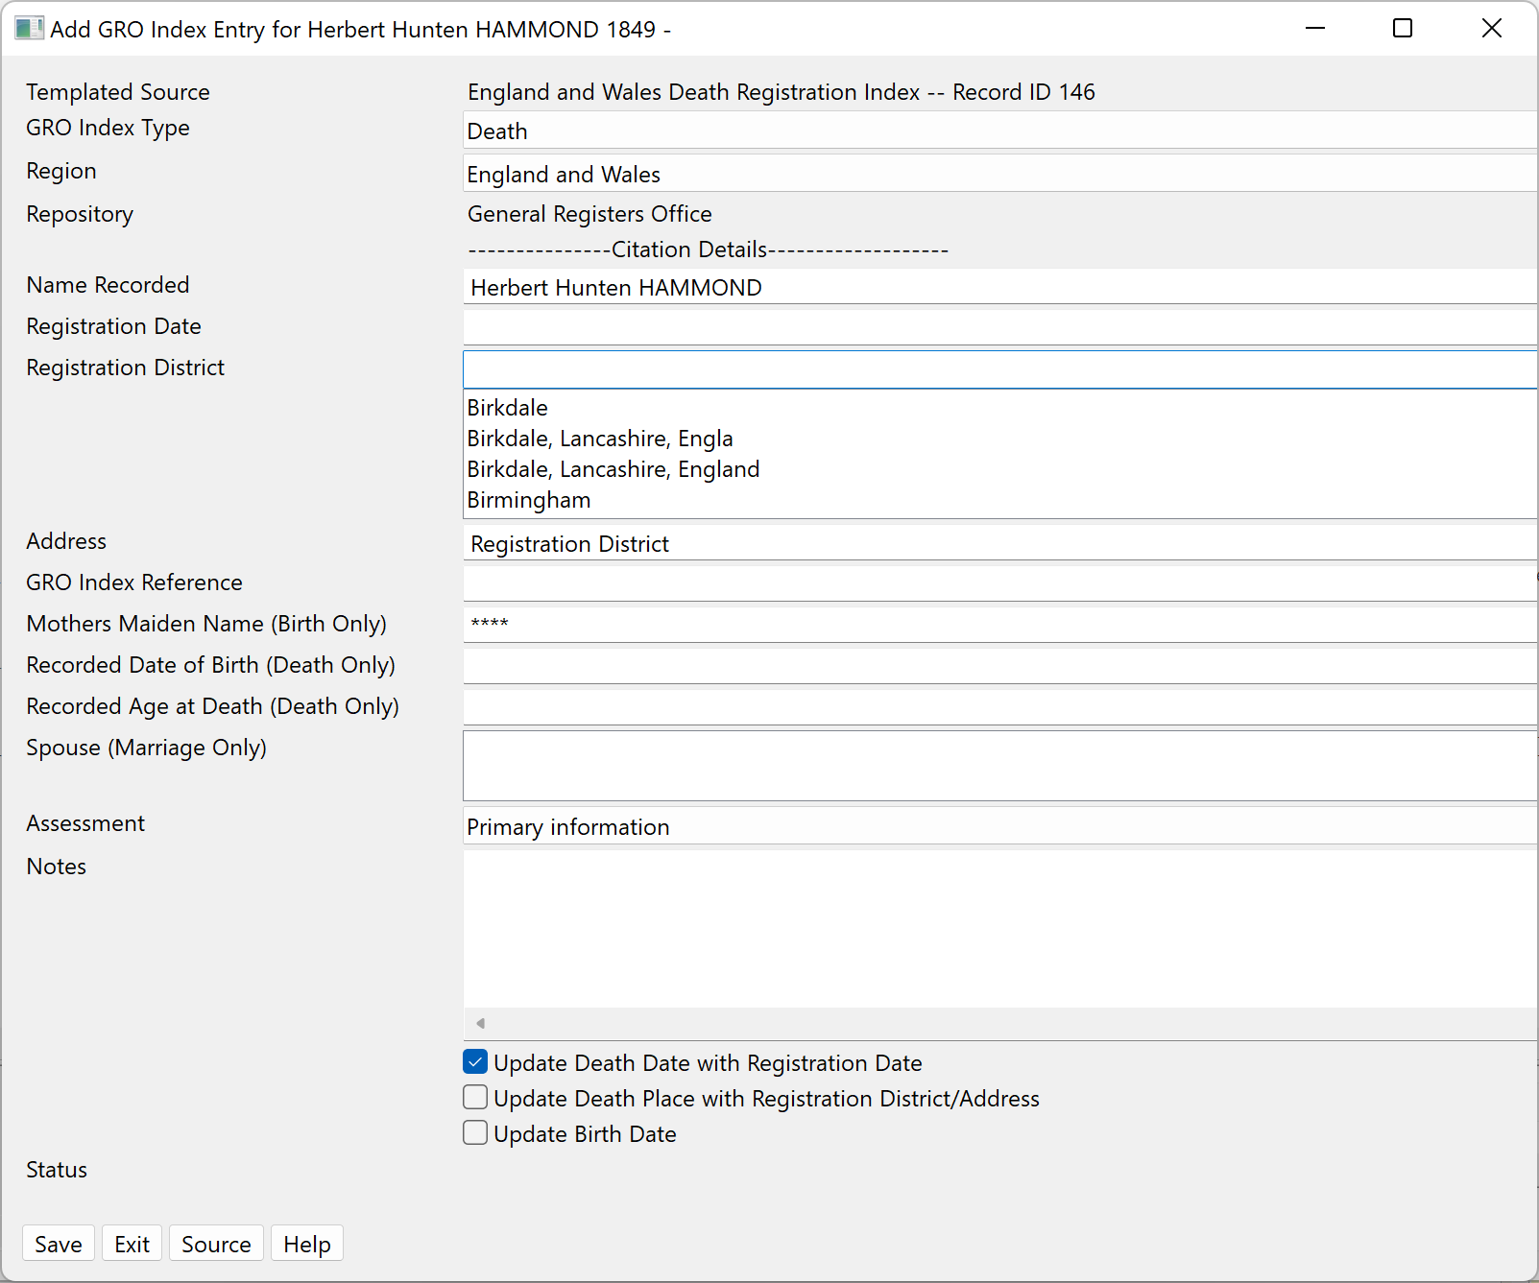
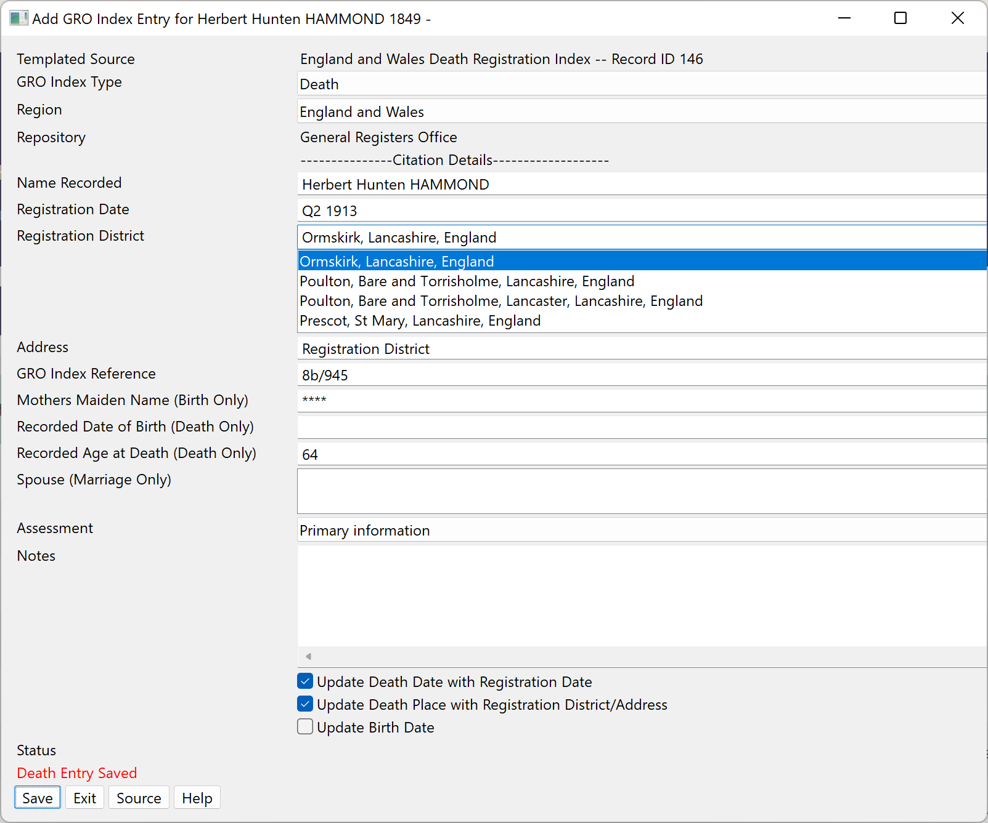
To allow for Birth, Marriage and Death to be recorded, the dialog is not closed, so press Exit to close the dialog.

